ACTIVITY 01 (Muhammad Anas)

The x and y points are x = [12, 15, 18, 21, 24, 27]

y = [2.14, 2.32, 3.01, 3.57, 4.04, 4.48]

**Plot the above points and an equation of function y = mx +c using online plotting tool.**

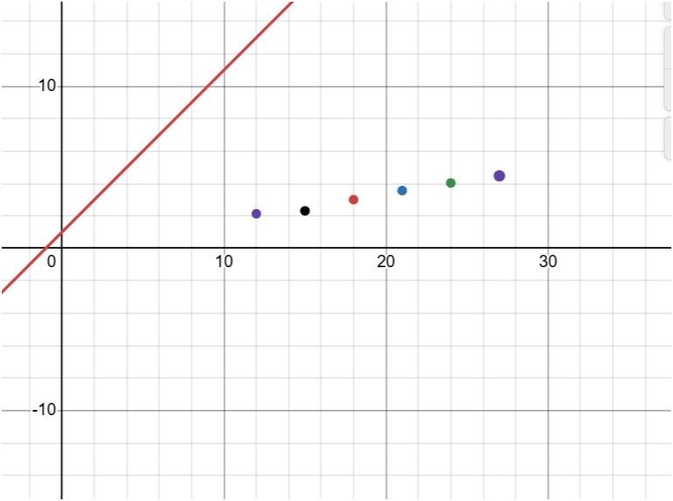

When we tweak the slope from 1 to 0.5 to be more inclined towards the points :

Then we observe slightly better approximation:

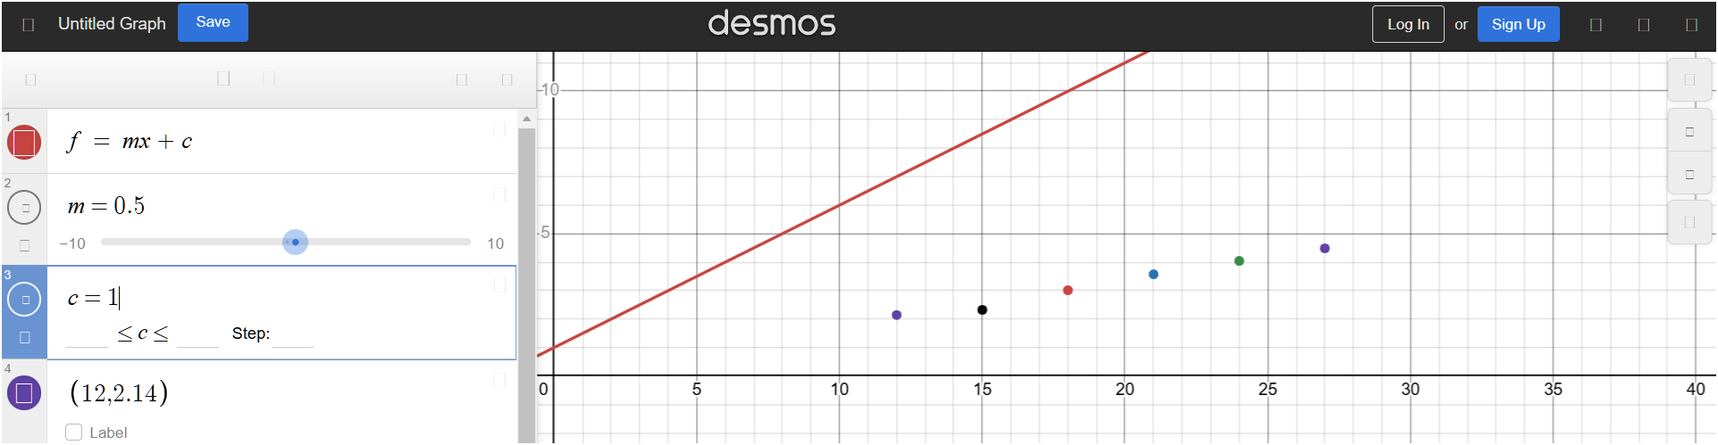

Clearly we need to decrease the y-intercept and slope few points so the line better coincides with the above dots, when after observing different values try with m = 0.1 and c = 1.1 I get loss(F) =

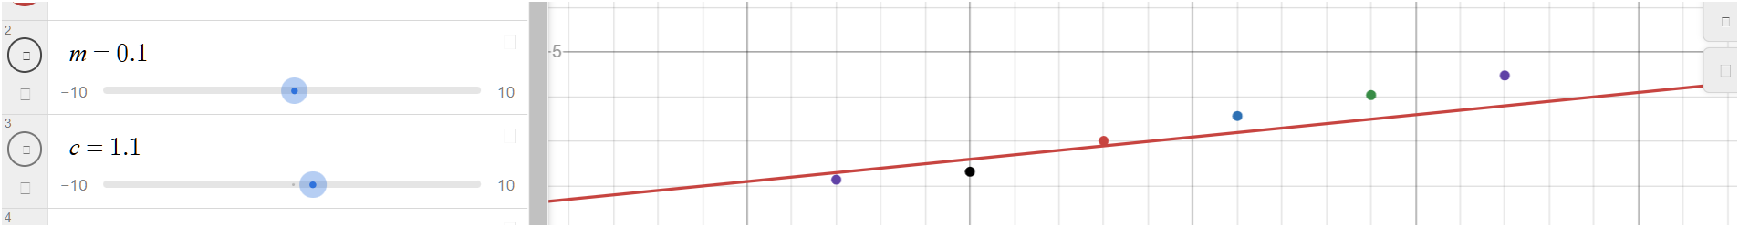

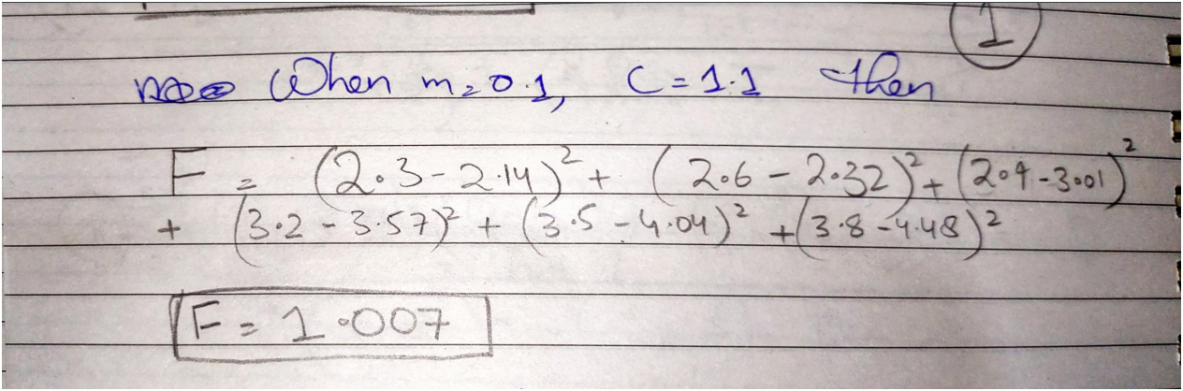

Now tweaking down the y-intercept we get a better approximation:

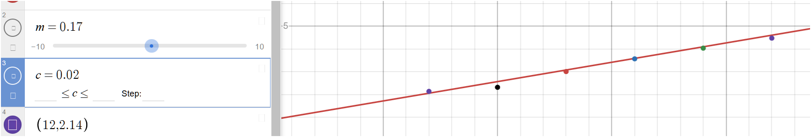

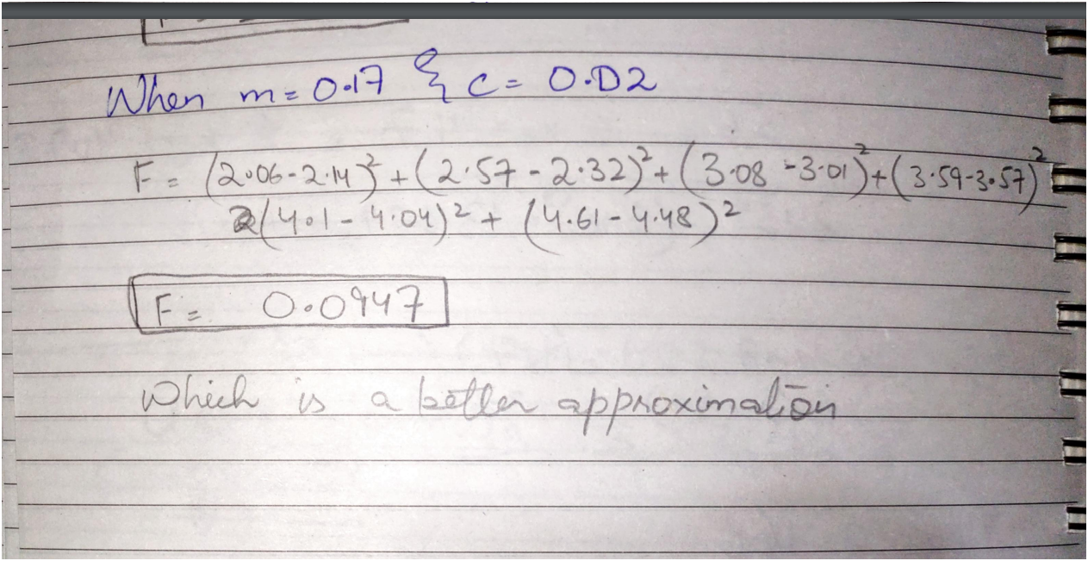

We can also confirm our loss functions output by determining the optimized values of m and c using the Regression Coefficients formula:

